**Problem Set 2**

This problem set covers material from OIS Chapter 2 Section 2.2 to Chapter 3 Section 3.1. It makes use of similar data to that we discussed in class. Partial credit may be given for answers that are correct in part, but not in full.

**Part I: The 2017 UK Election (48 points)**

Unlike the 2019 UK Election, the 2017 UK Election featured a close finish between the Conservatives (aka the Tories) and Labour. This section makes use of data from that election. (Note: Con=Conservatives, Green=Green, Lab=Labour, LD=Liberal Democrats, SNP= Scottish National Party).

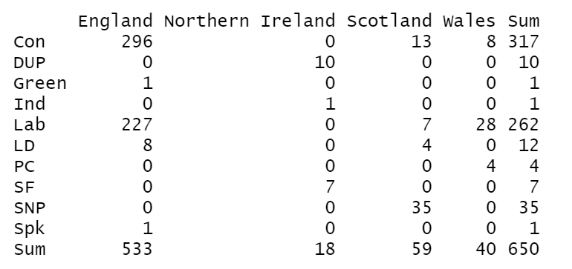

1. Below is a contingency table showing the number of seats won by each party by country. (16 points)
   1. Please calculate the row proportions for Labour for each country. You may use a calculator to divide large numbers, but please show how you get the numbers (8 pts.)
   2. Please calculate the column proportions for Scotland for each party. The above rules about calculators apply. (8 pts.)
2. Below is a stacked barplot I made in *R* that shows the results by country. I would like you to think about what the reader takes away from this visualization. (16 pts.)

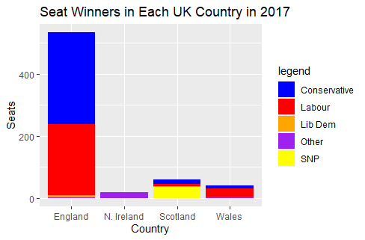

* 1. What is a benefit of using a stacked bar plot when considering the number of cases by country? What is a disadvantage when considering the relative number of seats won by a party within each country? (4 pts.)
  2. Let’s say you were most interested in having the reader know the relative number of seats won by party. What is an alternative type of bar plot you could make? Why would this type of bar plot do a better job of presenting this information to the reader? (4 pts.)
  3. Would a pie chart be a good way to display this data? Why or why not? (4 pts.)
  4. Imagine you were interested in having the reader know the percentage of cases won by a party within a country. What challenges might they face looking at the stacked bar plot? Are there any countries where this might particularly be a challenge? (4 pts.)

1. Below is an intensity map of the vote in the 2017 UK Election that shows the winning party in each seat and how strongly they performed that was created by [Alasdare Rae](http://ajrae.staff.shef.ac.uk/) at the University of Sheffield. Seats that are colored in with darker colors went for the party by a large margin, while those that are shaded in more lightly went for that party by a narrower margin. (6 pts.)

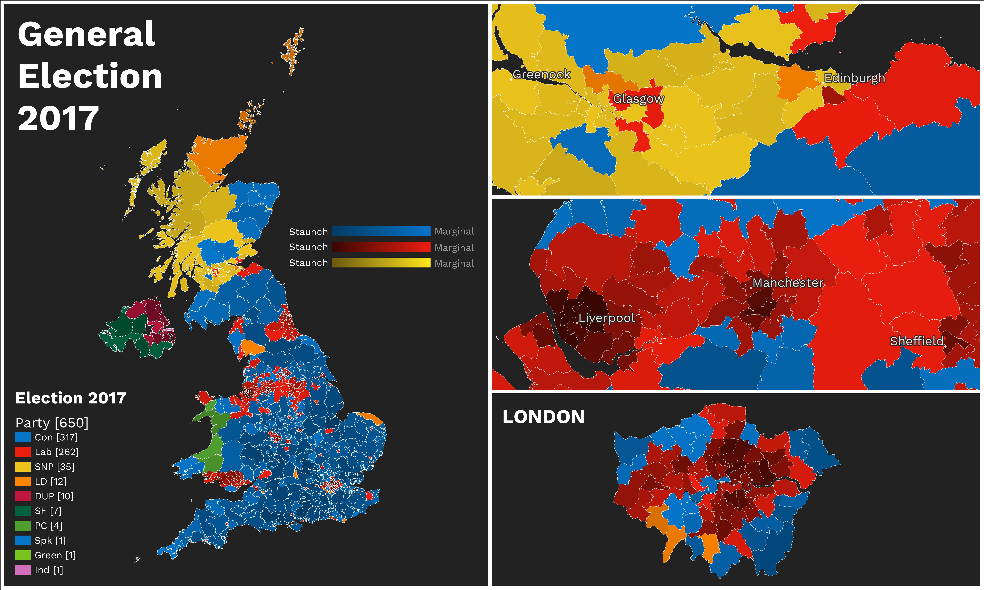

* 1. Which party tends to perform the strongest in cities in England like London, Liverpool, and Manchester? How do you know? (2 pts.)
  2. Which party won the northernmost seat in all of the UK? How do you know? (2 pts.)
  3. Where does the Conservative Party tend to perform most strongly? Please provide evidence for your answer. (2 pts.)

1. Now, you would like to look back at previous UK Elections. The below line graph, constructed by the UK Parliament’s [official website](https://commonslibrary.parliament.uk/research-briefings/cbp-7529/) shows the percentage of vote received by each party in the UK for the past 100 years. (10 pts.) (In the early years, the Liberal Democrat percentage represents their forerunners, the Liberals.)

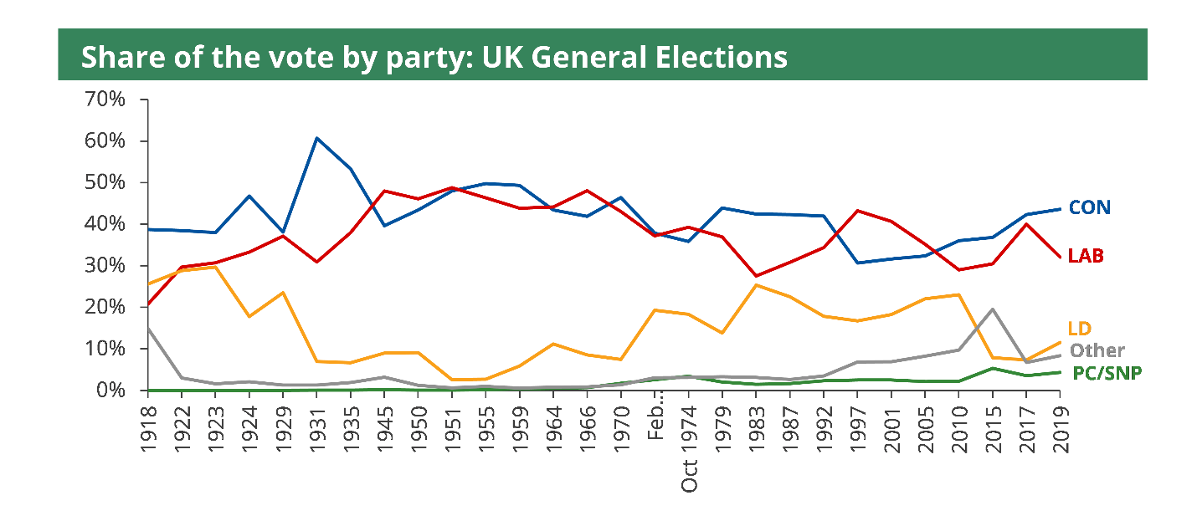

* 1. In which period(s) did the Conservative Party tend to be most dominant in UK Elections? When did Labour tend to do the best? When were the two parties most competitive with one another? (6 pts.)
  2. When did the Liberal Democrats tend to perform most strongly? Were they ever in the top two finishers in popular vote? (4 pts.)

**Part II: Probability and the 2018 Illinois 14th Congressional District Election (32 pts.)**

One of the final polls conducted by Siena College for the Upshot was in Georgia’s 6th Congressional District. This [poll](https://www.nytimes.com/interactive/2018/upshot/elections-poll-il14-3.html) had Democrat Lucy McBath ahead of incumbent Karen Handel by a 46-44% margin. On [Election Day](https://ballotpedia.org/Georgia%27s_6th_Congressional_District), McBath defeated Handel by one percentage point, 50.5% to 49.5%. This section’s questions focus on that poll and the election results in this district.

1. This chart shows how the result in the poll changed as more people were polled. This question focuses on this chart. (6 pts.)

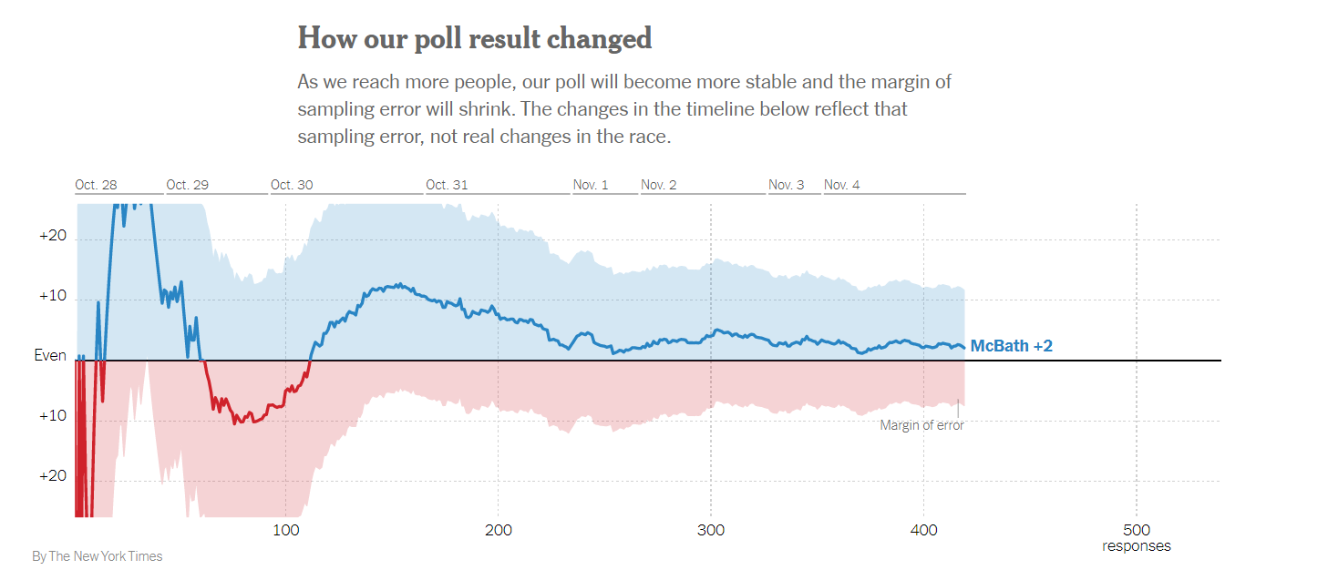

* 1. Why does McBath’s lead in the poll stabilize close to her actual margin on Election Day as the number of poll respondents goes up? What principle does this illustrate? (4 pts.)
  2. Let’s say we were to add an additional 500 respondents to this poll. Would we expect the margin to stabilize or begin to oscillate more? Why? (2 pts.)

1. Now please consider the actual results on Election Day (McBath 50.5%, Handel 49.5%) when calculating these probabilities. (26 pts.)
   1. What is the probability that a randomly selected voter is either an McBath voter or a Handel voter? Please show your work. (4 pts.)
   2. What is the probability that a randomly selected voter is an McBath voter and a Handel voter? Why is this the case? (4 pts.)
   3. Let’s say that you randomly selected 2 voters at random. What it is probability that they both would be McBath supporters? What is the probability that they both would be Handel supporters? Please show your work. (8 pts.)
   4. If you randomly selected 5 voters and all of them were McBath voters, are you “due” for a Handel supporter on your 6th draw? Thinking just about that draw, what is the probability of selecting a Handel supporter? (2 pts.)
   5. Approximately 10% of the world’s population is [left-handed](https://www.washingtonpost.com/health/the-big-number-lefties-make-up-about-10-percent-of-the-world/2019/08/09/69978100-b9e2-11e9-bad6-609f75bfd97f_story.html). If we assume that one’s dominant hand is independent from one’s political views, what is the probability that a randomly selected voters is left-handed and a Handel supporter? What is the probability that they are not left handed and a McBath supporter? (8 pts.)

**Part III: Probability, the Partisan Affiliation of State Attorneys General, and the Winning Party in 2016 Presidential Election (20 pts.)**

This section makes use of data on the current partisan affiliation of US state attorneys general and the results of the 2016 presidential election at the state level. In 2016, Republican nominee Donald Trump won 30 states and Democratic nominee Hillary Clinton won 20 states (for the purposes of this exercise, we are counting Maine as a Clinton win even though Donald Trump won one of their electoral votes that they allocate by congressional district winner.) Currently 26 states have Republican attorneys general and 24 states have a Democratic attorney general. (In a few states, Attorneys general are appointed, but in most they are elected.)

1. Here, I would like you to consider the probability of various outcomes when it comes to the partisan affiliation of Governors and a state’s vote in the 2016 presidential election. (20 pts.)
   1. The below probability distribution shows the four possible outcomes. Please fill in the two outcomes that are blank. Please show all of your work. (8 pts.)

|  |  |  |  |
| --- | --- | --- | --- |
| DPres, DAG | DPres, RAG | RPres, RAG | RPres, D Gov |
|  | 2% | 50% |  |

* 1. Here I gave you the number of states that both presidential candidates won. Imagine that you only knew the total number of states and the number of states that Clinton won. How could you find the percentage of states that Trump won? What does Clintonc represent here? (4 pts.)
  2. How many states have an attorney general from a different party than that of the candidate they voted for in 2016? Please show your work? (4 pts.)
  3. Looking at the above table, if you knew the party of the presidential candidate that won a state in 2016, would that help you guess the party of the state’s attorney general? Please explain your reasoning. Put differently, if I told you that Hillary Clinton won a state, what would be your guess for the party of the state’s attorney general? (4 pts.)